* **[How to publish an Access database](https://sharepoint.rackspace.com/learning/articles/Pages/SharePoint-2013--how-to-publish-an-access-database.aspx)**

The process for publishing an Access database in SharePoint 2013 is different than SharePoint 2010 which also has to do with the office version.  This demo will not cover creating an App within SharePoint 2013 but rather publishing or exporting an Access database to a SharePoint list.  Let’s begin!   
  
1. From Microsoft Access 2013 create or open a blank desktop database, in this example I will open a database I have already created called **Contacts**.

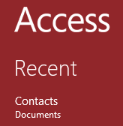

2. Within this database I have a table named **Clients**, I will double click to open.

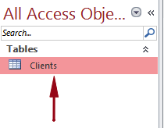

3. The Clients table will open and you can now see all of the data.

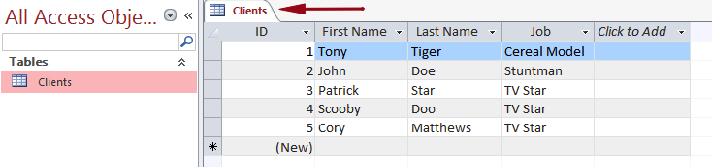

4. In the ribbon click **External Data**.

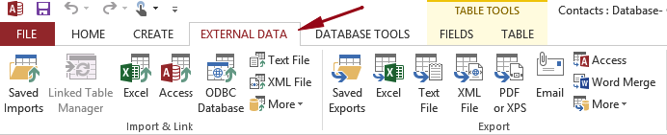

5. In the Export section click **More** and select **SharePoint List** from the drop-down.

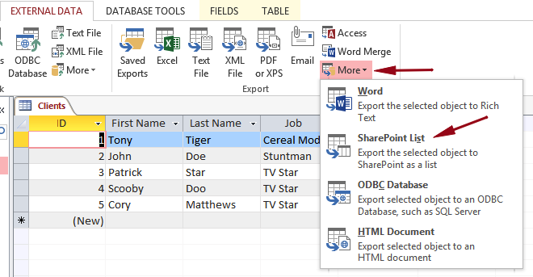

6. In the Specify a SharePoint site section enter your SharePoint site URL. In this example I will use https://scuba3.atrackspace.com

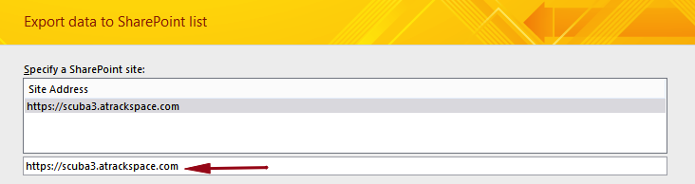

7. In the Specify a name for the new list section give it a name,  I will leave mine as **Clients**.  
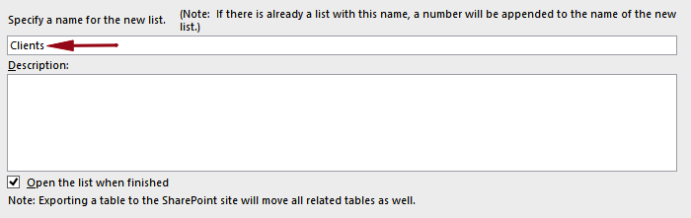

8. Leave the box checked next to "**Open the list when finished**".

9. Review your settings and click **OK**.  
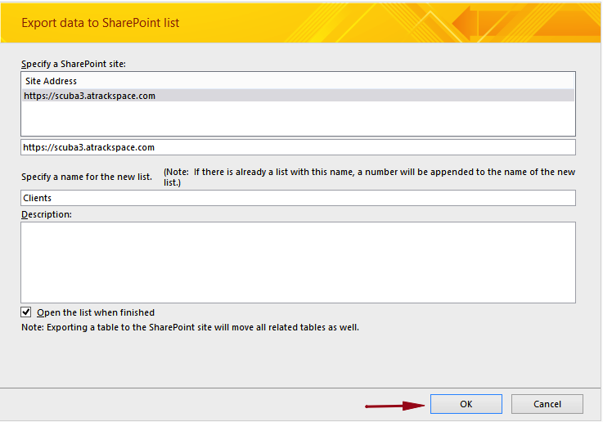

10. Enter your SharePoint user credentials, if prompted.

11. It will begin exporting your Clients table from Microsoft Access 2013 to a SharePoint list called Clients.   
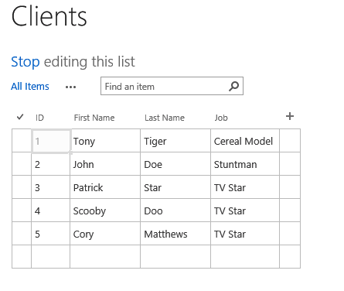

12. Click **Stop** editing this list to get out of the Quick Edit view.



13. It is as simple as that, it is important to understand though your Clients table in Access 2013 and Clients list in SharePoint 2013 are not synced.  This is possible but it will be covered in a different demo.

